**Together Apart process analysis**

**DESIGN PROBLEM AND GOAL**

COVID-19 has changed the way how we interact with space and people in a public setting. The goal of this project is to research and to design a 3D object that that will promote social distancing.

We designed a social distancing bench that will be place at the Vancouver Art Gallery North Plaza, šxʷƛ̓ənəq Xwtl'e7énḵ Square. The plaza is one of Vancouver’s most popular and visited area. The plaza serves as a pivotal location for protesters and for tourists. During our on-site research segment, we noticed that it lacks a resting area for visitors that is designed to adhere to COVID-19 social distancing regulations.

**CHOOSING THE LOCATION**

We chose the location to place this bench with the plaza traffic in mind – the flow of how people enter and exit the plaza. We filtered down to three locations to put the bench, which is shown in blue dotted rectangles, and we chose to place it along Hornby Street. We chose that spot because we expect the bench to be long to be able to practice social distancing. Hornby Street is also a popular bike route, so the bench can also provide a resting area for cyclists.

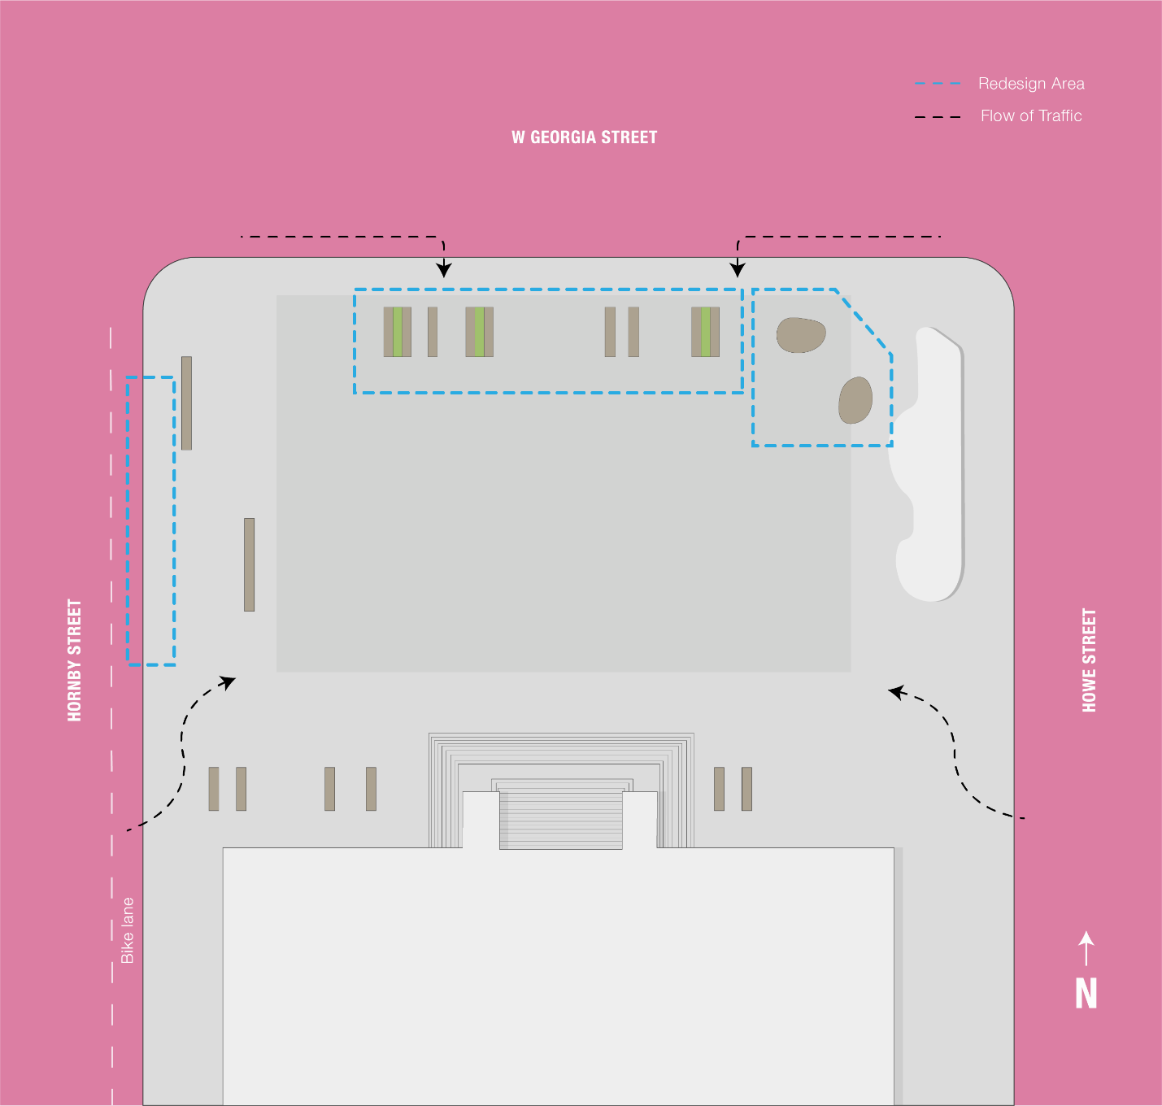

**DESIGNING THE BENCH**

Accessibility, function, and aesthetics are equally important.

**Accessibility:**

-18inches in height which is within recommended ADA compliance for outdoor accessibility

-flat bench with no metal bars to welcome patriots to use however they want

**Function:**

-Chair lights up when in use. Light gets dinner and turns off after 15 minutes to provide an approximate time to indicate the last time in use.

-2 meter distancing

**Aesthetics**

-no dividers to fit into the modern city

-Integrated planter

**IN THE MAKING**

Actual bench:

Concrete: suitable for outdoor furnishing

Wood:

Fabricated model:

Air dry modelling clay

3Dprinted filament

Multipurpose brown pain

Sing LED lights

**CONCLUSION**

This was a comprehensive project that requires research, design, and fabrication. During the research stage, it required us to learn about the needs of the user and the space. The research was difficult because it was in the time of a pandemic. It was difficult to do in person survey and observe how people use the space. We went to the plaza early in the morning, so it was not very busy at the time. The designing stage required a lot of empathy and understanding how the users will interact with the bench. Accessibility, function, and aesthetics were all taken into consideration. Since there are many different bench designs, it was difficult to design a new unique bench. For the fabrication stage, the biggest challenge was working with the air-dry clay because clay is prone to cracking. In conclusion, I learned that to design an object or a product, it is important to understand the users need and how they will interact with the product. Always be a mindful designer and keep accessibility in mind to not design any defensive design.